Dear Sir/Madam,
If you are having surgery with Dr Agar, Dr Dance, Dr Koh, Dr Liew or Dr Tan then the following applies. All other Doctors will supply you with a script for your post operative drops.
Your Doctor will ask the pharmacy (Customised Compounding) to supply you with Post Surgery Eye Drops (see photo below). You can NOT get it at a normal pharmacy as it is made for you.
- These drops will be given to you on the day of your surgery.
- The cost of these drops is $30 and is SEPARATE to your doctors fees.
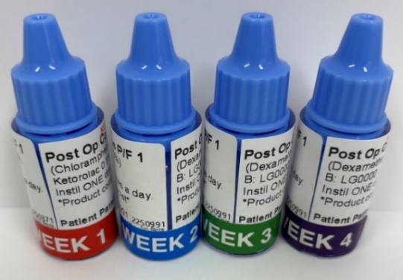
- These drops are not covered by Medicare and don’t go towards your Medicare Safety Net.
Please note:
- Keep the drops in the fridge.
- If going out for more than 1 hour, use a small cooling bag and icepack to keep the drops cool.
- You will need to use the drops for 4 weeks.
- We are here to help - our team will show you how use the drops on your day of surgery.
One (1) week before your surgery, please call 1300 725 868 to pay for the drops.
Payment options:
1. | Credit Card over the phone  1300 725 868 | To speak to our customer service team
2. | Pay via Westpac Payway site  by Scanning QR Code  and  enter Biller Code 305920 |   QR Code
3. | Direct deposit into our bank account | Bank Details  Account Name: Customised Compounding  BSB: 032 173 Acc Number: 769236  Please enter your full name and Doctor’s surname as a reference

If we have not heard from you, a Customised Compounding staff member will contact you before your surgery to organise payment.
Best Wishes,
Customised Compounding

